City of White Plains Parking App: Case Study of a Smart City Web Application
Ari Butowsky, Keke Gai, Michael Coakley, Meikang Qiu, and Charles C. Tappert
Seidenberg School of CSIS, Goldstein Academic Center, Pace University
Pleasantville, New York 10570
{ab90748n, mcoakley, mqiu, ctappert}@pace.edu
Abstract. The City of White Plains has a residential population of 57,000 people, which increases every day by 225,000 people who come in from the outlying suburbs to work and shop in the city. Due to the traffic created and the large number of spread-out parking locations, an app was created to allow drivers to find available parking spaces easily. The app navigates customers to parking structures in conjunction with their destination. The app’s user interface was constructed using HTML, CSS, and JavaScript, and a tag-based network structure to facilitate exploratory behavior. The research methodology used was action research and case studies. The work culminated in a completed user interface, a report detailing its perceived benefits, an evaluation of it and its application, an outline methodology for future work, and a discussion and evaluation of alternative tools and methods for developing such user interfaces.

1 Introduction
This paper concerns the development of a mobile Web app to facilitate the location of available parking spaces in a city. This app was developed in a capstone projects course at Pace University interacting with the City of White Plains as the customer for the project. Interestingly, upon completion of the project and becoming familiar with the possibilities, White Plains purchased a professionally-developed parking app from PassportParking [7].
The City of White Plains City (WP) is a growing central business and commercial city with a residential population of approximately 57,000 people. Known as one of the top suburban office and retail centers in the United States, the city boasts a massive number of public and private entities that draw commuters to it.
WP’s population increases by 225,000 people every day due to the influx of workers, shoppers, and visitors arriving by various means of transportation, especially by automobile, because the city has the following features [1]:

- Various establishments like restaurants, arts and cultural destinations, boutiques, and many others attract both visitors and residents.
- Downtown White Plains is a business hub, bringing law firms, major corporations, colleges/universities, and high technology firms to its doorstep.
- Schools provide top quality education and services for a large student population.
- Twenty electric vehicle charging stations are located in parking areas throughout the city.
- The Transit Center serves as a travel hub for commuters and serves as a gateway from New York City to Upstate New York.

These and other features illustrate why WP is such an attractive city for commuters and why there was the need to build so many parking centers and garages throughout the entire city. One of the problems with WP’s parking locations today is that they are scattered over a relatively large area. As a result of this, as well as the influx of commuters creating heavy traffic in the city, it is often problematic for the average person to travel around the city and to find parking places. This illustrates the need for a parking app that will facilitate and efficiently assist drivers in finding available parking space, and navigate customers to the nearest parking structure in conjunction with their destination location.

2 Comparison to Existing Parking Apps
There is already a mobile app for MapQuest that does something similar to the app being developed. To use the MapQuest app, one types in a destination and the app takes the user to that location, but data about pricing is not listed when it comes to parking locations. Another app is called BestParking, which provides a map of the parking areas in WP together with a list prices associated with each parking area. In addition, both MapQuest and BestParking can be used on various types of mobile devices, including Android, BlackBerry 10, iPhone, and iPad [2]. Lastly, there is the WP website, which provide all kinds of information about the city, but it is only a website and not a mobile app.
The WP parking app will be similar to these apps by containing data on the parking facilities in the city, including their locations, the prices of parking, and so on. However, the new app will also have a GPS function that will allow drivers to navigate through the city to find the nearest parking facilities quickly.

3 What Users Want from an App
Before developing the parking app, an analysis of the expectations from today’s mobile phone users and the difficulty in meeting these expectations was performed. Users expect to find speedy transitions from one Web page to the next, smooth load experiences, and application-centric error messages. Also, mobile phone apps are expected to be responsive even when network connectivity is spotty and the network is not highly responsive itself.
Meeting these demands is tough for mobile app developers. The old rules for creating and implementing websites on desktop computers will not work when they are applied to creating and implementing mobile web applications [6]. This is because not only could doing so degrade the performance of the mobile applications themselves, but it could also lead to the intended benefits of using the old approaches not being seen as opposed to when using them for creating websites on desktop computers. Therefore, new methods need to be created in order to make sure that mobile web applications are able to function properly.

4 Why a Web Application?
The reason for this app being a web application is due to the pros of developing it as such far outweigh the cons. In fact, the primary cons associated with building a web application are having to come up with one’s own payment system for the app, being unable to access some of the hardware features of the phone, and finding it difficult to create sophisticated effects on the user interface. These cons seem to be a small price to pay for designing a web application. It is clear that web applications allow more flexibility for the app developer in a wide variety of ways. For example, becoming a Web application developer does not require any money, one’s current web design and development skills are enough for the job, one’s current authoring tools can be used, the app will run on ANY device with a web browser instead of just on an Android phone, bugs in the app can be fixed at any time, and the development cycle for the app is faster than that for native applications. Simply put, web applications are more flexible and easier to build than native applications which is why a web application was built for this study [8].

5 Hardware and Software Details
The interface for the WP parking app was constructed so that it can be used on any type of mobile device. In order to do that, it must contain a variety of attributes that make it adaptable to any situation that comes its way.

5.1 Programming Languages Used
The interface was constructed using three computer languages: Hypertext Markup Language (HTML), Cascading Style Sheet (CSS), and JavaScript. An HTML document serves as the underlying structure of the created webpage, CSS is applied to the document to define its visual representation, and JavaScript code is added to make the webpage more interactive and convenient for the user. In summary, the web pages are HTML documents that are given visual representation by CSS and that become more interactive and convenient for users with JavaScript [8].

5.2 Maximizing User Interface Performance
To make the interface effective in terms of its performance as a mobile app, Hypertext Transfer Protocol (HTTP) requests and round trips were reduced significantly [6]. HTTP requests are sent by the web browser to the web server for a certain Web page in the URL when the page is loaded. When the HTML that structures the page is delivered, the web browser analyzes it and searches for more requests for images, scripts, and CSS, among other things. The more of these there are, the more HTTP requests there will be and the more time it will take for the Web page to load. Therefore, minimizing these HTTP requests is necessary in order for the WPC parking app to function effectively [3],[5].
Reducing HTTP requests can be done through the use of image maps, CSS sprites, and through combining various files together. Image maps are clickable regions on images that make links more visually appealing and the Web page more interesting. By combining these images into a CSS sprite (i.e. Splits a large image into many smaller images.), all site maintenance and navigation buttons will be scrunched up together into one file. With regards to using CSS, although using style sheets and scripts is necessary to keep various files from increasing the amount of time needed for a Web page to load, the app will have only one style sheet and script. This is because style sheets and scripts can interfere with the loading time of a Web page as well in when in greater numbers. In order to make this possible, the files containing each aspect of the app’s Web page will have to be combined into one.
As the file is sent, it is split up into individual packets that each take different routes before combining into their original form upon reaching their destination. Round trips are the process in which packets go from one destination to the other [9]. The time it takes for these packets to undergo this process should be reduced in order to make the mobile web application more efficient. In order to do this, all code, assets, and CSS for the website must load in just one round trip. Additionally, dynamic data were loaded separately and HTML5 storage APIs used to store/cache follow-on content [6].
Even though HTTP requests will be greatly reduced through these methods, it will all mean nothing without the proper network structure. For the WP parking app, it will be a tag-based network structure as opposed to the folder-based hierarchical structure seen on typical user-interfaces seen on mobile phones. A tag is a user-generated descriptor that refers to an aspect of content. It is usually visualized in a tag cloud, which is a depiction of frequently used tags. Clicking on a tag will lead to a colossal amount of content being displayed in association with that tag. However, this will only be possible if the tag-based network is installed on a D-button phone, a multi-display button phone in which each display button can present either content or contextual information individually and be pressed physically. A D-button phone has content or contextual information both on the main screen and the display buttons. It also provides preview thumbnails of media content while detailed content is shown on the main screen. This way, exploratory browsing depends on chance and it is affected by context since the D-button phone displays both a view of the context surrounding the content presented and a view of the actual content itself [4].

5.3 White Plains App Interface Main Webpage
The interface main webpage was created using both HTML and JavaScript. It includes a wide variety of features as seen in Fig. 1, including:

- Five hyperlinks at the top of the screen: HOME, ABOUT US, DEVELOPER, PARKING OPERATORS, and CONTACT.
- Textboxes where users enter data, including the distance between a parking location and the user, the time period when a parking lot is available, whether or not a certain type of parking is public or on-street, and departure and arrival times.
(Note: The word “Arrive:” is stated twice due to an error.)
- A “search” function that looks for which parking areas are available during specific times based on the user data entered in the textboxes.
- A Google Maps function that acts based on the data entered in the textboxes by the user.

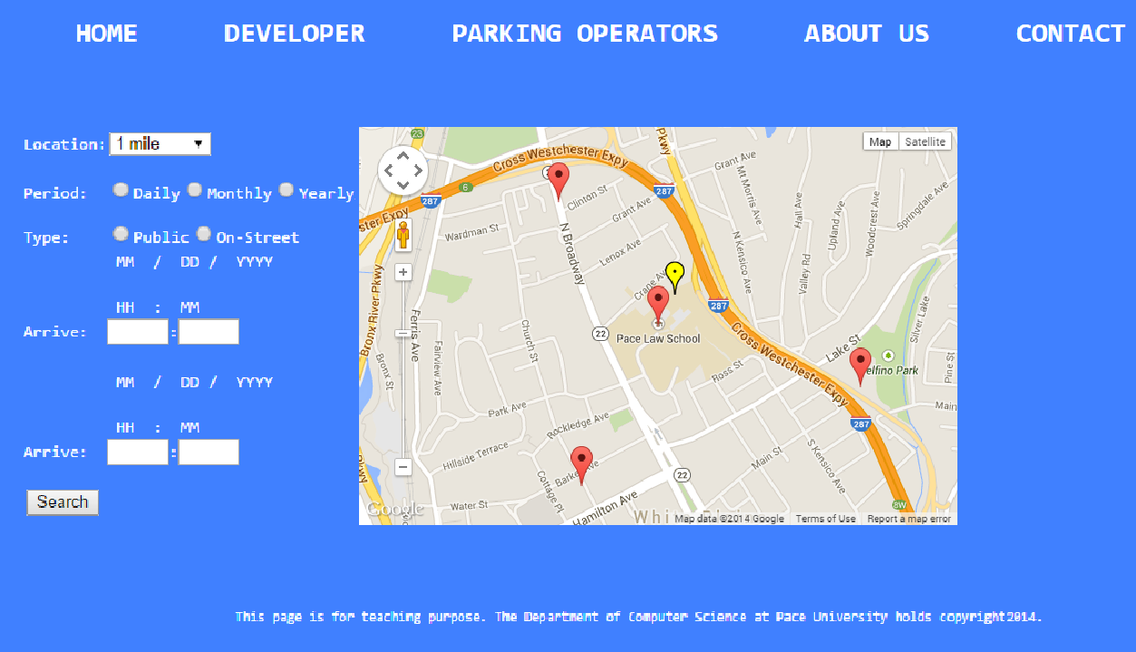
Fig. 1. Screenshot of interface main page.

Let’s say a person wants to find the Macys Parking Garage in White Plains City. First, that person has to open the GPS on the parking app so the app knows his location. Second, WPC would provide a system which relays information to the app about which spaces are occupied and which are open. Now, there can be calculations done by the city regarding information on paid-for parking services through metered payments, a satellite GPS system on each one of the parking spaces that works with the GPS system on the app, or there can be a computer calculator taking in information based on entering and exiting vehicles per lot. Whatever the case, information would be relayed to the app to tell the driver which parking lot closest to him has open parking spaces. That would be how the Macys Parking Garage would be found.
The purpose of this app is to make it easier for people to go to White Plains’ various retail spots and urban spots and spend money. It is good for any city that does not have a public transportation system. Cities without a public transportation system is a huge issue.
The reason this app should be used by White Plains is because by opening its GPS system, a person would be able to see all the data provided by WPC, making his experience less cumbersome and more enjoyable to come into the city, spend money, and subsequently raise the city’s revenue.

6 Conclusions

The WP parking app can provide people in White Plains with the ability to find the nearest parking locations and make navigation throughout WP easier due to the GPS navigation feature installed into the app. Since this feature functions using the data obtained from WP, it will provide accurate information on where various parking centers can be located. The data will also provide information on parking fees and where various electric car chargers are located, among other things.
In order to complete this app, a significant amount of action research was performed. Action research is the study of an attempt to solve a problem or change a situation. It involves working with a certain subject and evaluating the results. In the case of the WP parking app, the action research was conducted with various people, including several doctoral students from Pace University.
The outcome of this project was not only the creation of the WP parking app – its construction, evaluation, and effective performance. It also produced a written report with an explanation of the perceived benefits of this user interface, an analysis of the difficulties experienced in developing the user interface, a critical evaluation of the user interface and its application, an outline methodology for future user interface projects, and a discussion and evaluation of alternative tools and methods for developing user interfaces.
Customers of our projects sometimes use our projects to become familiar with what’s possible, and then deploy an application that is professionally developed because, in contrast to student-developed applications, it is maintained and easily upgraded to new versions. In this case, shortly after this project was completed, the City of White Plains finalized an agreement with Passport Parking [7] to become the City’s new “pay by phone” partner. In addition to providing customers with the traditional ability to pay for their parking spot via a toll free number, the agreement with Passport Parking also included the development of a mobile parking app. The app not only provides City drivers with customized mapping capabilities to identify the closest local parking structures, but it is also tightly integrated to the City’s existing meter and parking enforcement systems. The fee for the app is subsidized via a “convenience fee” paid for by the consumer, and ongoing upgrades and maintenance of the app are rolled into the master maintenance agreement that the City has entered into with Passport.
In other words, Passport Parking is like our app as a 2.0 version. Not only does it help people find suitable parking spaces, but it also allows them to activate parking sessions remotely. This is all done by entering one’s local zone number (i.e. Indicates where a person is parking. It is found near the bottom of Passport signage and decals on parking meters.), the space number in which one would like to park, and then selecting the duration of one’s stay in that specific parking space followed by the payment of both a parking and convenience fee.

7 Future Work
In the future, such applications will likely use Internet of Things (IoT) technology where the transfer of data over the internet uses machine-to-machine (M2M) connections without human interaction. For example, in a future parking app the automobile could interact directly with parking garages.

References
1. About White Plains. Web, (2014), http://www.cityofwhiteplains.com/index.aspx?nid=248
2. BestParking.com: Web, (2014), http://www.bestparking.com/
3. Johansson, J.: How To Make Your Websites Faster On Mobile Devices. Smashing Magazine, April 2013.
4. Kim, S., Lee, I., Lee, K., Jung, S., Park, J., Kim, Y.B., Kim, S.R., Kim, J.: Mobile Web 2.0 with Multi-Display Buttons. Communications of the ACM 53.1 (2010): 136-141.
5. Kyrnin, J.: Minimize HTTP Requests to Speed Up Page Load Times. About Technology. Web, (2014), http://webdesign.about.com/od/speed/qt/minimize-http-requests.htm
6. Nicolau, A.: Best Practices on the Move: Building Web Apps for Mobile Devices. Communications of the ACM 56.8 (2013): 45-51.
7. Passport.com, Web, (2015), https://gopassport.com/
8. Stark, J., Jepson, B., MacDonald, B.: Building Android Apps with HTML, CSS, and JavaScript. O’Reilly (2012).
9. TechTarget: Round-trip Time (RTT) Definition. Web, (2014), http://searchnetworking. techtarget.com/definition/round-trip-time

